Project Design Phase-II
Technology Stack (Architecture & Stack)
Date | 18 June 2026
Team ID | Individual
Project Name | ShopEZ – Full-Stack E-Commerce Application (MERN Stack)
Maximum Marks | 4 Marks

Technical Architecture
The deliverable below includes the architectural diagram for ShopEZ and the supporting component and characteristic information in Table 1 and Table 2.
Example: Request flow for an e-commerce transaction across the MERN stack
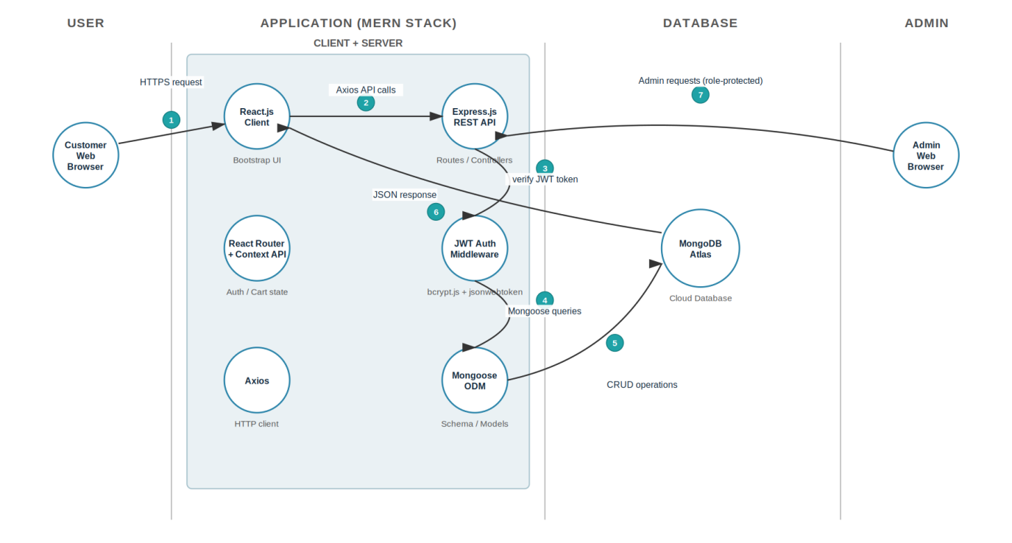
Figure 1: Technical Architecture — ShopEZ (MERN Stack on MongoDB Atlas)
A customer's browser sends an HTTPS request to the React.js client, which calls the Express.js REST API over Axios. Protected endpoints are verified by the JWT authentication middleware before Mongoose executes the corresponding CRUD operation against MongoDB Atlas; the JSON response then flows back to the client. The Admin browser reaches the same Express.js API through role-protected routes, reusing the identical authentication and data layers.

Table-1: Components & Technologies
S.No | Component | Description | Technology
1 | User Interface | Web UI through which customers browse products, manage their cart, place orders, and through which admins manage the store. | React.js, React Router DOM, Bootstrap 5
2 | Application Logic-1 | Handles user registration, login, password hashing and JWT-based session/role management. | Node.js, Express.js
3 | Application Logic-2 | Handles product catalog browsing, cart operations and order placement business logic. | Node.js, Express.js, Mongoose ODM
4 | Application Logic-3 | Handles admin-only operations: product CRUD, order status updates, and banner/category configuration. | Express.js admin routes & controllers with role-protection middleware
5 | Database | Stores Users, Products, Cart, Orders and Admin-configuration documents as JSON-like documents. | MongoDB
6 | Cloud Database | Fully managed, cloud-hosted database cluster used for all environments. | MongoDB Atlas
7 | File Storage | Product images and banner images are referenced via URL fields in the schema. | Static/local assets in development; external image hosting (e.g. Cloudinary) recommended for production
8 | External API-1 | Not used in the current scope of the project. | N/A
9 | External API-2 | Not used in the current scope of the project. | N/A
10 | Machine Learning Model | Not used in the current scope of the project. | N/A
11 | Infrastructure (Server / Cloud) | Local Server Configuration: Node.js + Vite dev servers on localhost.  Cloud Server Configuration: deployable to a Node hosting service with the client built and served separately or via a CDN. | Node.js runtime, npm scripts; Render / Railway / Vercel / Netlify for cloud deployment

Table-2: Application Characteristics
S.No | Characteristics | Description | Technology
1 | Open-Source Frameworks | The entire stack is built on freely available, community-maintained open-source frameworks and libraries. | React.js, Express.js, Mongoose, Bootstrap 5, Node.js
2 | Security Implementations | Passwords are salted and hashed before storage; sessions are stateless and verified via signed tokens; admin routes are protected by role checks; cross-origin requests are restricted to the known client origin. | bcrypt.js, jsonwebtoken (JWT), custom auth/isAdmin middleware, cors
3 | Scalable Architecture | A 3-tier architecture (presentation / application / data) with controllers, routes and models kept in clean, separate layers, allowing the client and server to be scaled or deployed independently. | Node.js + Express.js (stateless REST API), React.js SPA
4 | Availability | MongoDB Atlas provides built-in replication and automatic failover for the database tier; the stateless JWT-based API allows multiple server instances to run behind a load balancer without shared session state. | MongoDB Atlas replica set; process managers / cloud auto-scaling (e.g. PM2, Render)
5 | Performance | Frequently queried fields (e.g. product category) can be indexed for faster lookups; the client uses asynchronous Axios calls and component-level state to avoid unnecessary re-renders; Vite provides fast bundling and code-splitting. | MongoDB indexing, Axios, React Context API, Vite

